COME-IN! Label Call

Application Form

APPLICATION FORM

Thank you for participating!

With this form, you apply to the COME-IN! Label. There is an annual call for the application, so please refer to the rules and regulations to stay aware of the deadlines.

The COME-IN! Label was developed in the framework of the COME-IN! Project promoting accessibility and inclusion aiming at a museum experience for all. Before starting to fill in this form, please have a look at what it exactly refers to by exploring the different documents provided here: (https://www.cei.int/the-come-in-label)

Even if not all criteria are fulfilled and your facilities are not completely barrier-free, you may apply for the COME-IN! Label.

The application form investigates whether you are aware of what accessibility means and what steps you will take on the way to become accessible. If you take action to enhance accessibility, you can be eligible to the label. The form is also meant to explore what can be done for accessibility of your facilities.

Show us that you do care, commit and invest in your museum to become accessible to all!

Once you filled in the form, please send it with all extra material, to comein@cei.int

(Only digital material – no printed material to be sent).

Reminder: The plan of the application refers to the 4 main accessibility criteria developed and enhanced in the COME-IN! Project and Guidelines, and to administrative data. Throughout the evaluation process of your form, points will be awarded according to the level of completion in your museum and the scale of the following criteria:

- Access statement (25 points)
- Interactive exchange with people with disabilities (30 points)
- Staff training (25 points)
- Willingness and commitment to invest into accessibility and inclusion: Achievements in the past and action plan for the future (20 points)

Please complete the form in English!

Table of Contents:

1.) Basic information

2.) Access statement

3.) Cooperation with people with disabilities 4.) Staff training
5.) Achievements and Action Plan 6.) Declaration of Honour Appendix :
- Guide for the description of achievements and action plan

- Accessibility matrix

1.) Basic information

Name of the museum:
Organising institution: | ▢ public ▢ private
Street, no.:
Postal code, city:
Country:
Web:
Social media channels:
Opening date:
Kind of museum:
Focus of the exhibition:
Number of employees:
Number of employees with disabilities:
legal representative:
contact person:
phone:
e-mail:

2.) Access statement

Do you provide an Access Statement listing in clear form all the accessibility conditions and services provided by the Museum and information that could be relevant for people with disabilities? | ▢ yes ▢ no  ▢ in parts, please specify:
If yes, where can it be found? | ▢ own website  ▢ own printed material  ▢ verbal through staff  ▢ other sources, please specify:

Please add samples and/or examples of your Access statement to this form. Please provide a translation in English of its content.

3.) Cooperation with people with disabilities

A cooperation with people with disabilities is important to raise the right awareness for their needs and is the base for participation and inclusion.

Do you cooperate with people with disabilities in the museum work?

Yes, please specify the fields of work:
▢ design of the exhibition
▢ development of information material
▢ development of guided tours
▢ development of educational workshops
▢ staff training
▢ other

And please specify the field of accessibility:
▢ physical access
▢ access to information
▢ access to communication
▢ social access
▢ economical access
▢ other

Do you have association(s) for disabled people as partner(s) for your museum work?

▢ no
▢ yes, please specify

name of the association: seat:

Do you want to add something concerning the cooperation? Please fill it in here:

4.) Staff training

Staff training is essential to guarantee the provision of a good service to persons with disabilities.

Staff training has the following aims:

At raising awareness of the meaning of inclusion and accessibility;

At applying the procedures and use the tools available in the COME-IN! Framework for the purpose of accessibility;

At accompanying and offering proper services to single visitors or groups of visitors; At designing accessible exhibitions;
At offering accessible guided tours.

Has your staff been trained in field of accessible museums and interaction with people with disabilities?

▢ yes ▢ no

Are your following employees with or without disabilities trained to interact with customers with disabilities?

cash desk operators | ▢ yes ▢ no
wardrobe operators | ▢ yes ▢ no
tour guides | ▢ yes ▢ no
security operators | ▢ yes ▢ no
shop operators | ▢ yes ▢ no
follow-up operators | ▢ yes ▢ no
educational operators | ▢ yes ▢ no
curators | ▢ yes ▢ no
technical staff | ▢ yes ▢ no
cleaning staff | ▢ yes ▢ no

management | ▢ yes ▢ no

What was the scheme of the training (hours, content)?

When did the last training take place?

Are you interested in further training?

▢ yes ▢ no

5.) ACTION PLAN

What improvements and actions towards accessibility and inclusion did you achieve during the last years?
Please use the accessibility matrix provided in the COME-IN! Guidelines as well as the questions in the Appendix of this form.
Please specify what and when did you achieve the different described actions (5 pages max.).

Are there still barriers in your museum?
▢ yes ▢ no

If yes, which? (2.000 characters max.)

What is your action plan for the next 5 years?
Please use the accessibility matrix provided in the COME-IN! Guidelines, as well as the questions in the Appendix of this form.
Be as precise as possible in your description by describing both theoretical and financial plans. Please precise if you already have the finances to implement the described measures.

Do you collect feedback concerning accessibility from your visitors?

▢ yes ▢ no

If yes, how? (2.000 characters max.)

Additional information, photographs and documents

Please freely add descriptions on realised projects, made experiences, ideas you have concerning the accessible museum and already received accessibility awards:

You can add pictures about your work and your museum and/or additional documents.

(If your material exceeds 5 MB – please use www.wetransfer.com)

6.) DECLARATION OF HONOUR

I, the undersigned, Mrs/Mr. [NAME] (function), representing the museum [NAME], hereby certify that the above information submitted in the application form for the COME-IN! Label is exact.

Done at [NAME OF THE CITY],
Date:

[SIGNATURE]

Appendix

Guide for the description of achievements and action plan

This appendix shows some examples of questions that should help you write and design the description of your achievements and of your action plan. They are formulated in the spirit of the COME-IN! Guidelines that you should also have a look at while filling in the application form. Please feel free to address more aspects. (to be linked directly to the online COME-IN! Guidelines).

1.) Information and communication² before the visit

Is your website accessible? (Compliant with W3C levels A/AA or AAA³)
Does your webpage contain video components in sign language and audio description and simplified language or easy to read?
Are your printed information products available in Braille and tactile signage?
Are your printed information materials accessible for visually impaired? (font type, font size, visual contrast font/background etc.)

2.) Arrival:

- All information and data requires the 2-senses principle, i.e. be perceivable by a minimum of two senses out of three (hearing, sight and touch). All important information are accessible without assistance (e.g. information and data are available in simplified language, easy to read, videos in sign-language, subtitles and audio description).
- For further information: https://www.w3.org/WAI/standards-guidelines/wcag/

Does an orientation system outside of the museum provide accessible orientation signals for people with disabilities about how to find the entrance?
Is the physical access at the arrival in compliance with the national technical specifications?
Are reserved parking lots for people with disabilities available near the entrance of the Museum?
Is public transport with accessible characteristics available nearby the Museum?
Are tactile and/or sensorial trails available in the access area of the museum?

3.) Entrance:

Are orientation maps available in different formats (easy to read, Braille, tactile, audio) and provided in the entrance area?
Is the physical access to the entrance in compliance with the national technical specifications and therefore fully accessible?
Are the doors of the entrance hall in compliance with the national technical specifications?
Are height and depth of the stairs suitable to allow easy access to people with disabilities?
Is a suitable ramp or platform lift available?
Is there proper moving space to allow for example wheelchair users to move in comfort in the entrance area?
Are the floor conditions suitable for people with disabilities?

(Avoid rough lining (gravel, cobble, etc.), use lining that is rigid and not slippery, carpet
shouldn’t affect the driving behaviour)

4.) Cash desk:

Do you provide accessible information on pricing and exhibition?

Brochures/leaflets/banners are available in alternative formats (easy to read, big type, Braille, multimedia, audio, etc.)
Is the physical access to the cash desk in compliance with the national technical specifications?
Is the desk’s height and depth suitable for people with disabilities?
Has the cash desk area proper moving space to allow people with physical disabilities to move in comfort?
Is the access to the cash desk marked by tactile/sensorial trails?
Is the cash desk equipped with an inductive loop?
Is the cash desk marked in a clear and accessible way?

5.) Wardorbe:

Is the physical access to the wardrobe in compliance with the national technical

specifications?
Is the wardrobe accessible also for people with disabilities and is the wardrobe's height suitable for wheelchair users?
Are the lockers accessible also for people with disabilities?

(Lockers are provided with tactile/sensorial numbers and signs, hangers for clothes are positioned in different heights and moving space for wheelchair users is provided)
Is the wardrobe marked in a clear and accessible way?

6.) Exhibition area:

Is a clear and accessible information and orientation system (symbols, consistence, contrasts, etc.) of the exhibition available to guarantee all customers find autonomously their way in the exhibition rooms?
Are labels, panels and guides that describe artefacts available in different formats, e.g. simplified language and easy to read for all visitors?
Are Audio/Video/Multimedia/etc. guides available to guarantee accessibility to different visitor groups, e.g. sign-language, subtitles, audio description, etc.)?
Are support devices available for specific types of customers e.g. tour guide systems with sound induction systems, induction loop, magnifying lenses?
Is the physical access to the exhibition area in compliance with the national technical specifications?

Is the floor of the exhibition suitable for wheelchair users, baby buggies, walking frame, etc.?
Has the exhibition area proper moving space to allow people with physical disabilities to move in comfort?
If there are stairs, are alternative routes provided?
Is an accessible orientation system including tactile trails in the exhibition available?
Is there one route through the exhibition for everybody?
Are the artefacts of the exhibition positioned (height, view, etc.) in a suitable way to make them easily accessible to everybody?
Are chairs and sittings corners available in the museum/exhibition?

7.) Toilet:

Are the toilets clearly marked through an orientation system [signage]?
Is there information concerning the toilets in the entrance area in different formats (easy to read, simplified language, Braille, tactile, audio)?
Is the physical access to the toilet(s) in compliance with the national technical specifications?
Is the toilet suitable for wheelchair users and is one accessible toilet available in each floor of the exhibition?

Are the toilets accessible for people with disabilities using the Euro Key?

8.) Shop(s):

Are labels and pricing information easily readable for all visitors (contrast, font size, etc.)?
Are inclusive books (audio books, tactile, Braille, etc.) or guides available in the museum shop?
Is the physical access to the shop(s) in compliance with the national technical specifications?
Are the doors of the shop(s) in compliance with national specification to allow easy access to people with disabilities?
Does proper moving space allow all visitors to move in comfort in the shopping area, with a suitable exposition of goods?
Does the cash desk have a lowered area to ensure dialogue of equals?

9.) Output – information and communication after the visit:

Is the feedback tool positioned in an accessible way in a clearly recognizable area at the end of the exhibition (or at the exit of the Museum)?
Is the feedback collected via forms available in different formats and supported by audio help?

10.) Economical access:

This chapter is about the equality of costs for people with and without disabilities.

Any kind of information, communication and services should be available for people with disabilities in the same way as it is for people without disabilities.

Do you raise an extra fee for:
- Information in easy to read or Braille?
- Personal Assistants of people with disabilities?
- Parking of Personal Assistants of people with disabilities?
- Wardrobe services for people with disabilities?
- Toilet services for people with disabilities?
Do guided tours for people with disabilities cost more than guided tours for people without disabilities?

The Service Chain Accessibility Requirements

This section was developed during the COME-IN! Project and is explained in the COME-IN! Guidelines. For more information on how to read and to fill in the matrix below, please refer to the COME-IN! Guidelines here: (to be linked).
It is an important tool when planning investments and accessible activities.
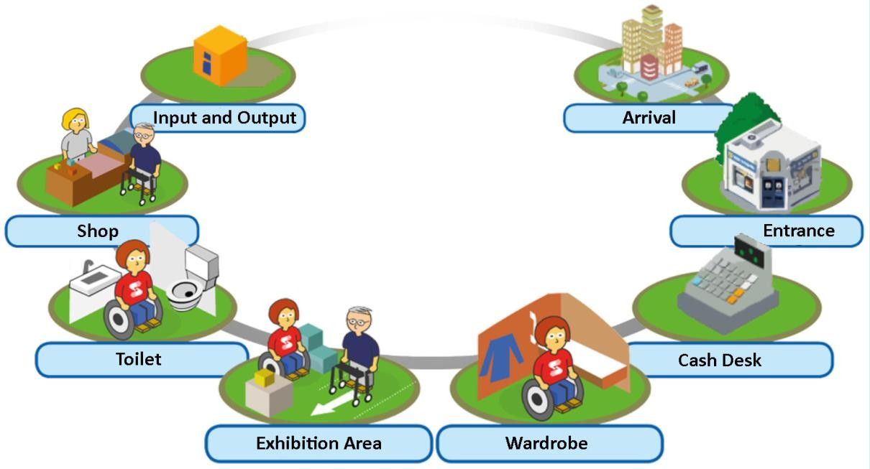

The present Service Chain is an example for a typical museum. The Service Chain is a tool to ensure or evaluate consistent accessibility to a museum. It defines all aspects that are relevant for visitors of a museum. Generally speaking, a Service Chain of a museum should consider the following components:
  - Input - Information and communication before the visit
  - Arrival
  - Entrance
  - Cash desk
  - Wardrobe

  - Exhibition area
  - Toilet
  - Shop
  - Output - Information and communication after the visit

COME-IN! accessibility criteria are based on the Service Chain elements cross-checked with the four relevant aspects of accessibility:
  - physical access
  - information and communication access
  - social access
  - economical access

Accessibility  Service chain | Physical access | Information and communication  access | Social access | Economical access
Input
Arrival
Entrance
Cash desk
Wardrobe
Exhibition area
Toilet
Shop
Output

The Service Chain analysis based on this matrix can be adjusted individually according to the respective museum. The matrix can be used to check whether the current situation in the museum is compliant or not with the requirements described in the COME-IN! Guidelines. The Matrix defines only minimum standards. If there is nothing filled in, this does not mean there are no requirements possible.

The benefits of using the Service Chain as a tool to evaluate the accessibility are:

  - complete evaluation of all relevant areas and services,
  - structured procedure,
  - consideration of the access for ALL visitors.

